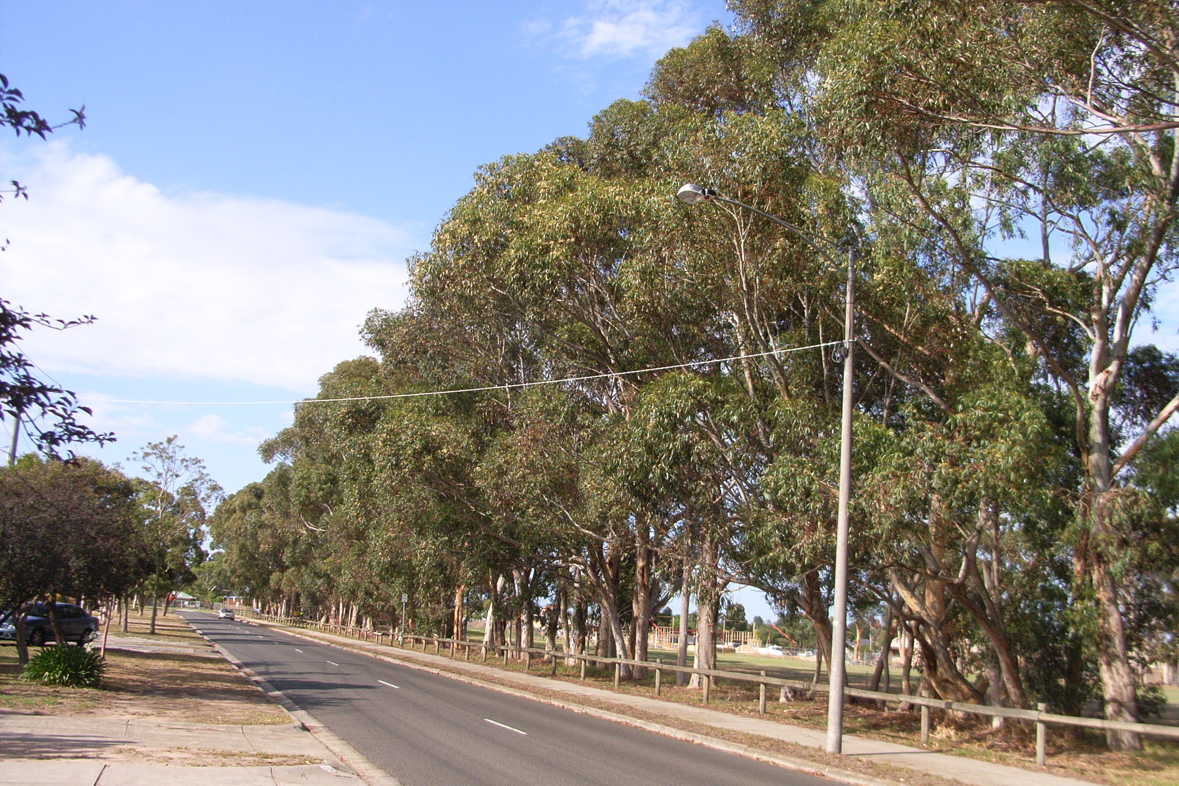

Photo: January 2008

Existing designations:
Heritage Council Register: Nil
National Estate Register: Nil
National Trust Register: Nil

Description: A row of approximately 50 sugar gums (Eucalyptus dadocalyx) located along the east boundary of the former Brandon Park Secondary College site adjacent to Strada Crescent. Almost all of the trees are considered to be mature with only a couple of small trees, possibly being regrowth from past coppicing. All trees are approximately 20-25 metres in height and with canopy spreads of approximately 20 metres.

Condition: Fair. The trees within the row display fair health typical of the species in such an environment.

Integrity: Medium. A long row exists with approx. 50 trees. A section is towards the southern end of the row. Several trees have had at least one leader removed in the past with some tress having the typical resultant regrowth that has altered the form of several of the trees. The strong continuous form of the windrow however, is still evident

History: The Sugar Gum plantation along Strada Crescent, Wheelers Hill marked a boundary on the Brandon Park Estate. The property on the corner of Springvale and Ferntree Gully roads, was owned by Sir George Steward (1865-1920), who named it Brandon Park. At this time, 1902, Steward was Secretary to the Governor General. The property was sold on to the Chirnside Family in 1921 who ran it as a Jersey Stud. The property remained as a farm until 1965 when it was sold to a developer. Land at the corner of Springvale and Ferntree Gully roads was transformed into a shopping centre and named Brandon Park after the estate. The land where the trees are located was used for the Brandon Park Technical School (later Secondary College) in 1978.

The stand of trees, probably planted around the time of World War Two marked a boundary on the property and provided a wind break. The trees formerly extended further north along what is now Strada Crescent to Ferntree Gully Road. The planting of both natives and various types of pine trees to provide windbreaks and indicate boundaries was a common practice in the Mulgrave / Glen Waverley area when the land was mainly given over to agricultural pursuits, particularly market gardening. The Monash Heritage Study of 1998 listed 12 similar stands or hedgerows. Similar plantations can also be found in Doncaster and Springvale. As such the trees are of local interest only and are a remnant of the early agricultural history of what is now Monash.

References-:
- .

Thematic Context:
Developing local, regional and national economies:
- Developing Primary Production

Statement of Significance: The row of sugar gums along the Strada Crescent boundary of 6-30 Brandon Park Drive, originally planted to provide a windbreak and indicate a boundary, is historically important (Criterion A) through its association with the former farm. The trees are also a valued landscape feature (Criterion E).

Recommendations:
- Recommended for inclusion in the Schedule to the Heritage Overlay in the City of Monash Planning Scheme.

Assessment:
Heritage Victoria – September 2006
Arboricultural Assessment and Report – Treelogic – January 2008

