21.04 RESIDENTIAL DEVELOPMENT
17/11/2011 C90
21.04-1 Overview
DD/MM/YY
Proposed C129

The City of Monash is a well-established, residential and business region in the city of Melbourne. It has suburban characteristics with established canopy treed environments throughout the municipality, identified heritage areas and an urban character enjoyed by the community.
Like the rest of metropolitan Melbourne, the City of Monash is experiencing a change in the housing structure and dwelling requirements of its population, with a noticeable shift towards increased density forms of housing, generally characterised by multi-unit dwellings.
The age of the dwelling stock within the municipality, which generally decreases as distance from the city increases in an easterly direction, lends itself to renewal. Original blocks tend to be greater than 650 m². This size facilitates development of dual occupancy and sometimes more intensive redevelopment. Accordingly there is considerable scope for change of housing stock and style.
This changing form of development, by design, has significantly reduced both the canopy tree environment and landscaped area, while increasing the hard surface coverage of each development site. This adversely impacts on Garden City Character of the municipality.
Council's goal is for residential development in the City to be balanced in providing a variety of housing styles whilst remaining sympathetic to existing neighbourhood character.
To partially compensate for the damage to the environment caused by the changing form of development, the strategies and polices of this Planning Scheme identify the need to maintain street setbacks and minimise street crossings to retain the image of green landscaped streets, provide adequate areas of private open space for recreation purposes as well as to enable planting of new canopy trees on site. These design outcomes are supported by planting and other landscape works within the public realm of streetscapes.
In addition, Monash’s population is noticeably ageing and there is a clear preference for older people to remain in familiar environments within the municipality. This changing demographic requires strategies to ensure there is appropriate accommodation, such as small, single storey units and purpose built housing available now and into the future.
The City of Monash has reviewed and drafted the Monash Housing Strategy (June 2004) which allows Council to plan proactively and strategically for the future housing needs of its residents having regard to issues such as neighbourhood character, environmentally sustainable development, access and safety, and greater affordability. The strategy also provides greater certainty for the community and the development industry regarding the location and type of future residential development.
Heritage
Significant buildings and some of the older areas around Oakleigh have identified heritage value. Housing styles and characteristics vary from workers row housing to larger homes, some with leadlight windows and extensive exterior decorations. These heritage buildings and areas are identified for conservation to ensure the neighbourhood character is maintained and complemented by any infill development.
Heritage issues are addressed further in Clause 21.12.

Neighbourhood Character
The evolution of Monash’s residential areas has been documented in the Monash Urban Character Study.
Monash City Council commissioned the Urban Character Study (1997) to identify and evaluate urban character within the City and to develop strategies for its management. This was originally documented in the Monash Urban Character Study- Volumes 1 & 2, (Gerner, 1997), which identified five (5) residential character types, containing sixteen (16) sub-types and 118 precincts, across Monash. An additional character type was later identified through the Waverley Park Concept Plan (August 2002).
Experience in using the Neighbourhood Character Study has identified an inconsistency in the classification of various properties within the definition of the character types and precincts identified in the Urban Character Study. This has resulted in the introduction of a separate Character Type G, for the more recent residential estate subdivision areas that have created their own built form identity.
The 7 Residential Character Types are:
- Type A Character derived from Pre-First World War and Inter-War development on flat topography and a grid subdivision pattern.
- Type B Character derived from 1945-1965 development, flat topography and a grid subdivision pattern.
- Type C Character derived from Post-War to 1965 development, undulating topography with a dominant N-S, E-W grid with some diagonal distortion.
- Type D Character derived from 1950’s public housing, sloping topography to Gardiners Creek and a gently curvilinear subdivision pattern.
- Type E Character derived from Post 1965 development, sloping topography to Dandenong Creek and a curvilinear subdivision pattern.
- Type F Character derived from Post 2002 comprehensive planning and development, elements from past use as an AFL ground, the undulating topography and available views and vistas.
- Type G Character typically derived from the form of subdivision layout and the built form development of each residential estate.
Map 3 shows identified residential character type areas.
The existing character, contributory elements and desired future character statements have been detailed for each residential character type and are outlined in Clause 22.01 Residential Development and Character Policy.
New development should be carefully designed and sited to complement the current character and satisfy the intent of the desired future character statements for each residential character type as identified. Garden City Character within all residential areas should be maintained and enhanced.
Where new development does occur it should respond to and enhance the quality and style of surrounding development.
Monash City Council is committed to managing the ongoing process of incremental change that is occurring across its urban areas. Some of these areas possess a special leafy character, valued by the community.

New residential development
There is an increasing demand for a variety of different housing styles to cater for changing household sizes and structures. State Government policy encourages higher housing densities near transport hubs and activity centres, such as Glen Waverley and Oakleigh.
Retention of neighbourhood character in residential areas will be enhanced by the identification of preferred areas for medium to high rise residential development within the municipality. These areas are generally within the Principal and Major Activity Centres, but may also include identified urban renewal sites.

In other areas new residential development will generally be low rise. The exceptions will be where there is an approved Structure Plan, or other planning mechanism in place or where individual circumstances support an alternative height.
Map 3: Neighbourhood Character Precincts in Monash
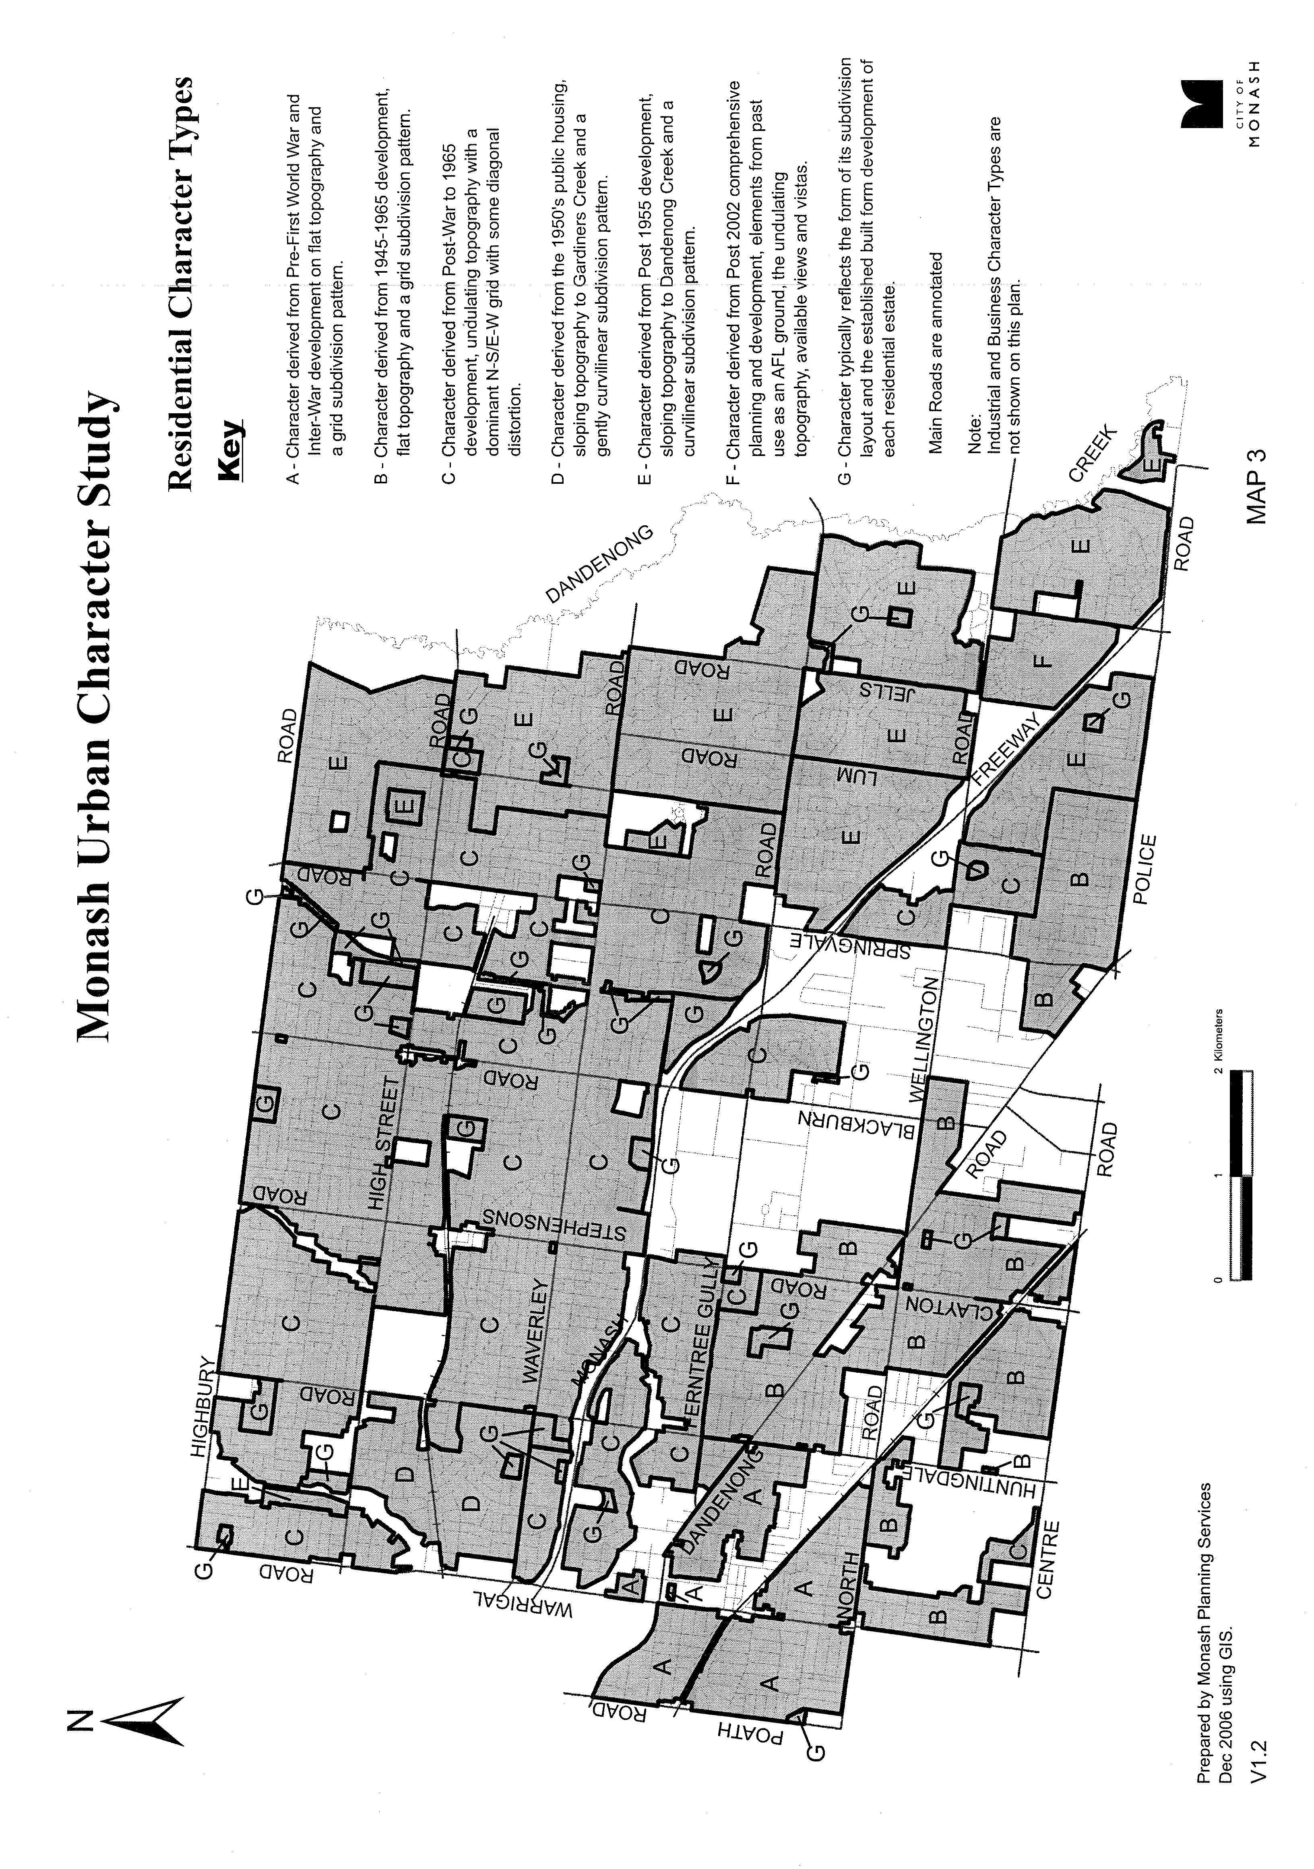

21.04-2 Key issues
17/11/2011
C90

- Residential development and housing are influenced by global factors such as the drive for more sustainable living practices, regional changes in demographics, lifestyle choices and housing markets, as well as local factors such as cultural elements, heritage, the location of employment and level of economic development.
- The population in Monash is noticeably ageing, resulting in a shift in the demographic nature of the community. The needs of an older population are likely to differ from the existing urban conditions.
- Changes in lifestyle choices and family structures in Melbourne have resulted in a notable decrease in the number of persons per household and changes in housing preferences towards lower maintenance homes. This is evidenced in an increasing need for more diverse forms of housing within the municipality.
- Demand for quality student accommodation has outstripped the local supply in some areas of Monash, which has resulted in housing shortages and a significant number of students living in substandard, shared housing facilities.
- Current suburban form is predominantly single dwellings on large blocks. These circumstances are supportive of infill development.
- The retention of neighbourhood character and enhancement of the Garden City Character image is very important to the Monash community and redevelopment needs to be respectful of these character considerations.
- Monash contains many locally significant assets, residential buildings, places and streetscapes of importance to the Monash community.

21.04-3 Objectives, strategies and implementation
DD/MM/YY
Proposed C129

Objectives
- To encourage the provision of a variety of housing styles and sizes that will accommodate future housing needs and preferences of the Monash community that complement and enhance the Garden City Character of the City.
- To provide accommodation for a diverse population that caters for different family and lifestyle preferences and a variety of residential environments and urban experiences.
- To recognise and provide for housing needs of an ageing population.
- To ensure the accommodation needs of students are met.
- To encourage high standards of architectural design in buildings and landscaping associated with residential development that takes into account environmental constraints including soil erosion, urban water management and fire risk.
- To encourage building practices and dwelling preferences that are energy efficient and sustainable and that incorporate landscape design and use of construction materials that minimise environmental impacts.
- To ensure that heritage dwellings and precincts are identified and conserved.
- To recognise the need to conserve treed environments and revegetate other areas including new residential developments to maintain and enhance the Garden City Character of the municipality.
- To ensure that development is appropriate having regard to the residential environment of the area, in particular neighbourhood character and amenity.
- To ensure appropriate infrastructure is provided to meet changing community needs that also complies with the principles of environmentally sustainable development.
Strategies
- Ensure that new residential development enhances the character of the neighbourhood, having regard to the preferred character statements contained within Clause 22.01.
- Ensure that development enhances the Garden City and landscaped streetscape character of the neighbourhood, responds to the features of the site and surrounding area and promotes good streetscape design.
- Ensure that new residential development provides a high level of amenity including personal privacy for occupants and neighbours, high quality private and public open space, canopy tree cover, and effective traffic management and parking.
- Maintain the predominantly single detached dwelling style in urban areas by promoting low rise development as the preferred character for the majority of the residential areas within the City.
- Direct high rise residential developments towards the Glen Waverley Principal and Oakleigh Major Activity Centres. These centres are well serviced by public transport, commercial, recreational, community and educational uses.
- Direct medium rise development towards the Brandon Park, Clayton and Mount Waverley Major Activity Centres and identified urban renewal sites, including the former Talbot Avenue Quarry in Oakleigh South.
- Ensure that new residential development achieves high quality architectural and urban design outcomes that positively contribute to neighbourhood character.
- Promote and facilitate housing projects that will result in a mix of housing types including mixed use developments in appropriate locations, such as “shop top” dwellings within the retail and commercial centres of activity centres, as well as over car-parks and other appropriate areas.
- Address the interface between activity centres and residential areas through innovative and high quality architectural design, appropriate setbacks and landscaping.
- Promote a variety of dwelling sizes and types to promote greater affordability of housing and choice in medium and large urban developments.
- Encourage the provision of high quality student accommodation in preferred locations such as in proximity to education facilities, activity centres and areas with good access to public transport, which minimises potential conflicts with neighbouring uses.
- Encourage the provision of single storey and purpose built housing to cater for Monash’s ageing population.
- Locate social housing or housing that meets special needs close to public transport and retail and community facilities.
- Encourage site consolidation to facilitate better design solutions, maintain existing canopy trees and achieve high design standards.
- Minimise the environmental impact on waterways within the catchment through adoption of best practice water sensitive urban design techniques and practices which result in improved stormwater management, water conservation and waste minimisation.
- Encourage vegetation retention on redevelopment sites.
- Address the problems of inadequate physical infrastructure by ensuring that new development satisfactorily provides for the infrastructure requirements it generates, particularly stormwater drainage.
- Encourage residents and developers to reduce, re-use and recycle household and construction materials.
Implementation
These strategies will be implemented by:
Policy and exercise of discretion
- Using local policy to improve the standard and quality of the design and construction of new developments. (Residential development and character policy, Clause 22.01, Stormwater management policy, Clause 22.04 and Tree conservation policy, Clause 22.05, Non-Residential Use and Development in Residential Areas Policy, Clause 22.09).
- Using local policy to facilitate the provision of high quality student accommodation in preferred locations, which are appropriate in terms of neighbourhood character, the provision of car parking, open space, student amenities and landscaping, and are suitably operated and used in an ongoing manner. (Student Accommodation Policy, Clause 22.10).
- Applying creative design solutions that enhance the quality of all areas particularly in relation to streetscape issues, scale of buildings, sustainable development practices, provision of open space and setbacks to ensure adequate landscaping of frontages.
- Ensuring that new development which is likely to impact on the capacity of existing infrastructure contributes to improvements and additions to physical infrastructure, including drainage and public open space.
Zones and overlays
- Applying the Residential 1 and 2 Zones, Mixed Use Zone and Comprehensive Development Zone.
- Applying the Vegetation Protection Overlay to areas which possess a special leafy character, valued by the community.
- Applying the Heritage Overlay to designated precincts, buildings and places.
- Applying the Neighbourhood Character Overlay to identify specific neighbourhood character objectives for special areas.
- Applying the Land Subject to Inundation Overlay and Special Building Overlay to ensure that development does not impact the flow characteristics of a flood event and ensuring minimum risk to human life and property, whilst protecting environmental values of floodways.
- Applying a Design and Development Overlay or Development Plan Overlay to ensure that the design and development of an area of particular interest achieves the desired goals of Council.
- Applying an Environmental Audit Overlay where appropriate to ensure that the condition of a development site is suitable for a residential or other sensitive use.
Further strategic work
- Implementing the Monash Housing Strategy (2004).
- Reviewing and/or preparing structure plans for the Glen Waverley Principal and Oakleigh Major Activity Centres and other areas identified as suitable for high rise residential development within the municipality.
- Undertaking the ongoing review of heritage buildings and locations within Monash and implementing the recommendations through appropriate planning scheme amendments.
- Reviewing the performance of policies and guidelines on a regular basis and making appropriate modifications.
- Investigating the feasibility of providing incentives for developers to build a variety of housing types that are available to all socio-economic groups in the Monash community.

Other actions
- Planning, developing and adequately financing the timely and equitable provision of physical infrastructure and human services.
- Promoting and strengthening the community’s recognition of the special character and identity of their local area.
- Maintaining an understanding of the adequacy of housing around employment centres to ensure that appropriate and timely responses can be developed to meet any future changes.

21.04-4 Reference documents
17/11/2011
C90

Oakleigh Heritage Study, 1991
Monash Urban Character Study, Gerner Consulting Pty Ltd
- Volume 1 - Assessment Report, January 1997
- Volume 2 – Citations, January 1997
Monash Neighbourhood Character Guide, Gerner Consulting Pty Ltd
- Volume 3 - Private Development, January 1997
- Volume 4 - Public Infrastructure and Assets, January 1997
- Volume 5 - Medium Density Housing, June 1997
Monash Heritage Study, Gerner Consulting Pty Ltd and Andrew Ward, February 1999
Oakleigh Shopping Centre Urban Design Framework, Context Conybeare Morrison etc. July 2002
Waverley Park Concept Plan, August 2002
Monash Housing Strategy, Essential Environmental Services, 2004
Sustainable Communities Framework, V.G. Urban Solutions & City of Monash, 2004
Strategy for an Aging Community 2002 – 2011
City of Monash Student Car Parking Study, O’Brien Traffic, July 2009

